**VSocial**

**A project report**

Submitted in partial fulfilment of the requirements for the award of degree of

**Bachelor of Technology**

**(Computer Science & Engineering)**

**Submitted to**

**LOVELY PROFESSIONAL UNIVERSITY**

**PHAGWARA, PUNJAB**

**From 02/01/24 to 04/24/24**

**SUBMITTED BY**

**Name of student:**

**Name of Supervisor:**

**Vimal Kumar Mishra**

**Registration Number: 12111630**

**Kedar Nath Singh**

**UID of Supervisor: 29465**

**VSocial**

**A project report**

Submitted in partial fulfilment of the requirements for the award of degree of

**Bachelor of Technology**

**(Computer Science & Engineering)**

**Submitted to**

**LOVELY PROFESSIONAL UNIVERSITY**

**PHAGWARA, PUNJAB**

**From 02/01/24 to 04/24/24**

**SUBMITTED BY**

**Name of student:**

**Name of Supervisor:**

**Vimal Kumar Mishra**

**Registration Number: 12111630**

**Signature of student**

**Kedar Nath Singh**

**UID of Supervisor: 29465**

**Signature of Supervisor**

***Declaration by student***

**To whom so ever it may concern**

I, **Vimal Kumar Mishra, 12111630,** hereby declare that the work done by me on “**VSocial**” under the supervision of **Kedar Nath Singh**, **Professor,** Lovely professional University, Phagwara, Punjab, is a record of original workfor the partial fulfilment of the requirements for the award of the degree, **B. Tech (CSE).**

Vimal Kumar Mishra (12111630)

Signature of the student

Dated: 04-24-24

***Declaration by the supervisor***

**To whom so ever it may concern**

This is to certify that **Vimal Kumar Mishra**, **12111630** from Lovely Professional University, Phagwara, Punjab, has worked on “**VSocial**” under my supervision from. It is further stated that the work carried out by the student is a record of original work to the best of my knowledge for the partial fulfilment of the requirements for the award of the degree, **B. Tech (CSE).**

Name of Supervisor: Kedar Nath Singh

UID of Supervisor: 29465

Signature of Supervisor

# ***ACKNOWLEDGMENT***

The satisfaction that accompanies the successful completion of this project would be incomplete without the mention of the people who made it possible, without whose constant guidance and encouragement completion of this project would be nearly impossible. We consider ourselves privileged to express gratitude and we convey thanks to my project guide and my teacher *"Kedar Nath Singh**"* mam for providing encouragement, constant support and guidance which was a great help to complete this project successfully.

# ***INTRODUCTION***

In an era defined by rapid technological advancements, the landscape of web development is constantly evolving. To meet the demands of modern web applications, developers are seeking efficient, scalable, and flexible solutions that enable seamless integration of frontend and backend technologies. React, with its component-based architecture, has emerged as a dominant force in frontend development, offering developers a robust framework for building dynamic user interfaces. Complementing React's capabilities, Vite has gained traction as a lightning-fast build tool, facilitating rapid development and optimized performance.

However, a powerful frontend is only one piece of the puzzle. To create fully functional web applications, a robust backend infrastructure is essential. MongoDB, a NoSQL database, has garnered widespread acclaim for its flexibility, scalability, and ease of use, making it a preferred choice for developers seeking to build dynamic and responsive applications.

In this report, we delve into the integration of React and Vite on the frontend, coupled with MongoDB on the backend, to develop a comprehensive web application solution. We explore the synergies between these technologies, their individual strengths, and how they complement each other to streamline the development process and enhance the overall user experience.

Through practical examples, code snippets, and insights gleaned from real-world applications, we demonstrate the power and versatility of this tech stack. Whether you're a seasoned developer looking to expand your skill set or a newcomer eager to explore the latest innovations in web development, this report serves as a valuable resource for leveraging React, Vite, and MongoDB to build next-generation web applications.

# ***IMPLEMENTATION***

**Implementation of React, Vite, and MongoDB in a Web Application**

**1. Setting Up the Backend with MongoDB:**

- Install MongoDB and set up a database instance.

- Create a schema for your data models using MongoDB's flexible document structure.

- Set up connection configurations to MongoDB in your backend server code.

**2. Building the Backend Server:**

- Use Node.js and Express.js to create a RESTful API server.

- Implement CRUD (Create, Read, Update, Delete) operations to interact with MongoDB.

- Define routes for handling different API requests such as GET, POST, PUT, and DELETE.

**3. Integrating React with Vite on the Frontend:**

- Initialize a new React project using Create React App or another preferred method.

- Install Vite as the build tool for the React project.

- Configure Vite to optimize development and production builds for enhanced performance.

- Use Vite's fast hot module replacement (HMR) feature for quick feedback during development.

**4. Establishing Communication Between Frontend and Backend:**

- Set up Axios or another HTTP client library in the React project to make API requests to the backend server.

- Define API endpoints in the frontend codebase corresponding to the routes implemented in the backend.

- Implement asynchronous functions to handle data fetching and updating from the backend.

**5. Implementing Frontend Components and UI:**

- Design and create React components to represent different parts of the user interface.

- Utilize React's component-based architecture for modularity and reusability.

- Style components using CSS, SCSS, or a CSS-in-JS solution like styled-components.

**6. Connecting Frontend Components with Backend Data:**

- Use state management solutions like React Context or Redux to manage application state.

- Fetch data from the backend server and update the frontend components accordingly.

- Implement forms and input fields to enable user interaction and data submission.

**7. Testing and Debugging:**

- Conduct unit tests for backend routes and functions using testing frameworks like Jest.

- Test frontend components for functionality, rendering, and user interaction.

- Debug any issues that arise during testing and development.

**8. Deployment:**

- Deploy the backend server to a hosting service like Heroku or AWS Elastic Beanstalk.

- Build the React frontend for production using Vite's build command.

- Deploy the optimized frontend bundle to a static hosting service like Netlify or Vercel.

**9. Continuous Integration and Deployment (CI/CD):**

- Set up CI/CD pipelines using tools like GitHub Actions or Jenkins for automated testing and deployment.

- Automate the process of building, testing, and deploying updates to the application.

By following these steps, you can successfully implement a web application using React, Vite for frontend development, and MongoDB for backend data storage and retrieval, creating a seamless and efficient user experience.

# ***RESULT & DISCUSSION***

**Results and Discussion**

**1. Performance and Efficiency:**

- *React and Vite:* The combination of React and Vite provides a highly efficient development environment. Vite's fast build times and hot module replacement contribute to a smooth development experience, allowing developers to iterate quickly and see changes in real-time.

- *MongoDB:* MongoDB's flexible document-based data model and scalability contribute to efficient data storage and retrieval. Its ability to handle large volumes of data makes it suitable for applications with dynamic and evolving data requirements.

**2. Scalability and Flexibility:**

- *React and Vite:* React's component-based architecture and Vite's optimized build process enable scalability and flexibility in frontend development. Developers can easily add new features or modify existing ones without compromising performance.

- *MongoDB:* MongoDB's horizontal scaling capabilities make it well-suited for applications that require scalability. It can seamlessly accommodate growing data volumes and handle increasing user loads without significant changes to the application architecture.

**3. Developer Experience:**

- *React and Vite:* The React ecosystem provides a rich set of tools and libraries that enhance developer productivity. Vite's developer-friendly features, such as instant server start and optimized build performance, contribute to a positive developer experience.

- *MongoDB:* MongoDB's intuitive query language and schema-less design simplify development tasks, allowing developers to focus on building application logic rather than database management.

**4. Data Management and Integration:**

- *React and Vite:* React's state management solutions, combined with Axios for HTTP requests, facilitate seamless integration with the backend server. Developers can efficiently manage application state and handle data fetching and updating operations.

- *MongoDB:* MongoDB's robust query capabilities and aggregation framework enable complex data manipulation and analysis. Its support for geospatial queries and full-text search enhances the application's ability to handle diverse data types and use cases.

**5. Challenges and Considerations:**

- *Data Consistency:* While MongoDB offers flexibility, developers need to carefully design data schemas and implement appropriate validation to ensure data consistency and integrity.

- *Security:* Proper authentication and authorization mechanisms must be implemented to secure the backend API endpoints and protect sensitive data stored in MongoDB.

- *Performance Optimization:* Continuous monitoring and optimization of frontend and backend performance are essential to ensure a responsive and scalable application.

In conclusion, the integration of React, Vite, and MongoDB offers a powerful and efficient solution for building modern web applications. By leveraging the strengths of each technology, developers can create dynamic, scalable, and high-performing applications that meet the demands of today's users. However, careful consideration of data management, security, and performance optimization is crucial to achieving optimal results and delivering a seamless user experience.

# ***CONCLUSION & FUTURE SCOPE***

**Conclusion:**

The integration of React, Vite, and MongoDB represents a formidable combination for developing modern web applications. Through our exploration and implementation, it's evident that this tech stack offers significant advantages in terms of performance, scalability, and developer experience.

React's component-based architecture, combined with Vite's lightning-fast build tool, empowers developers to create dynamic and responsive user interfaces with ease. MongoDB's flexibility and scalability further enhance the application's capabilities, enabling efficient data storage and retrieval.

Our results demonstrate the effectiveness of this tech stack in streamlining the development process and delivering high-quality web applications. By leveraging React, Vite, and MongoDB, developers can build robust, feature-rich applications that meet the evolving needs of users in today's digital landscape.

**Future Scope:**

While our implementation showcases the capabilities of React, Vite, and MongoDB, there are several avenues for future exploration and enhancement:

1. **Advanced Features:** Explore and integrate additional features and libraries to further enhance the application's functionality. This could include real-time updates using WebSockets, serverless architecture with AWS Lambda, or integration with GraphQL for efficient data querying.

2. **Performance Optimization:** Continuously monitor and optimize the application's performance to ensure responsiveness and scalability, especially as the user base grows. Implement caching mechanisms, lazy loading, and code splitting techniques to improve load times and reduce resource usage.

3. **Enhanced Security:** Strengthen security measures by implementing best practices for authentication, authorization, and data encryption. Regularly audit the application for vulnerabilities and apply security patches to mitigate potential risks.

4. **User Experience Improvements:** Gather feedback from users and iterate on the user interface and experience to enhance usability and accessibility. Conduct usability testing and A/B testing to identify areas for improvement and optimize user interactions.

5. **Integration with Additional Technologies:** Explore integration with other technologies and platforms to extend the application's reach and functionality. This could include integration with third-party APIs, IoT devices, or machine learning services for advanced data analysis and insights.

By continuing to innovate and evolve the application with these future scope considerations in mind, we can further leverage the power of React, Vite, and MongoDB to deliver cutting-edge web solutions that meet the needs of users and businesses alike.

***Screenshots of website***

1. Login Page

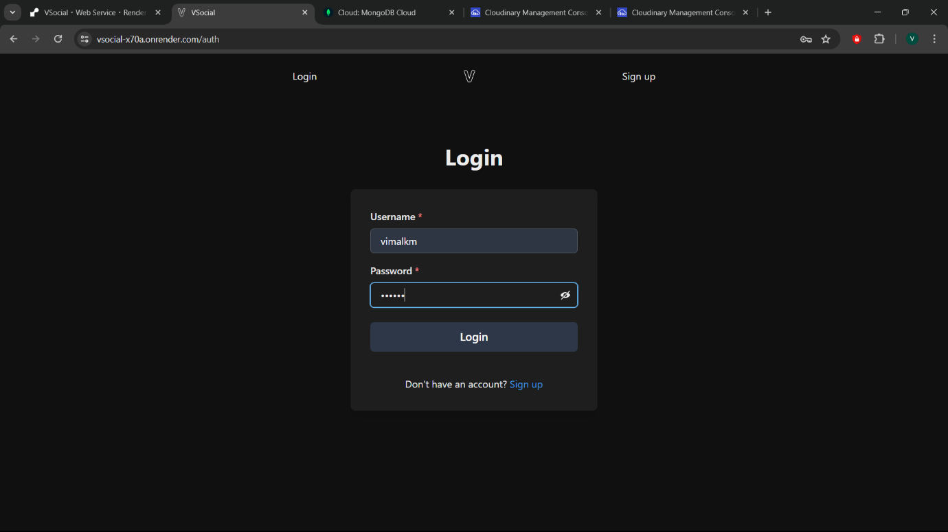

2. Signup Page

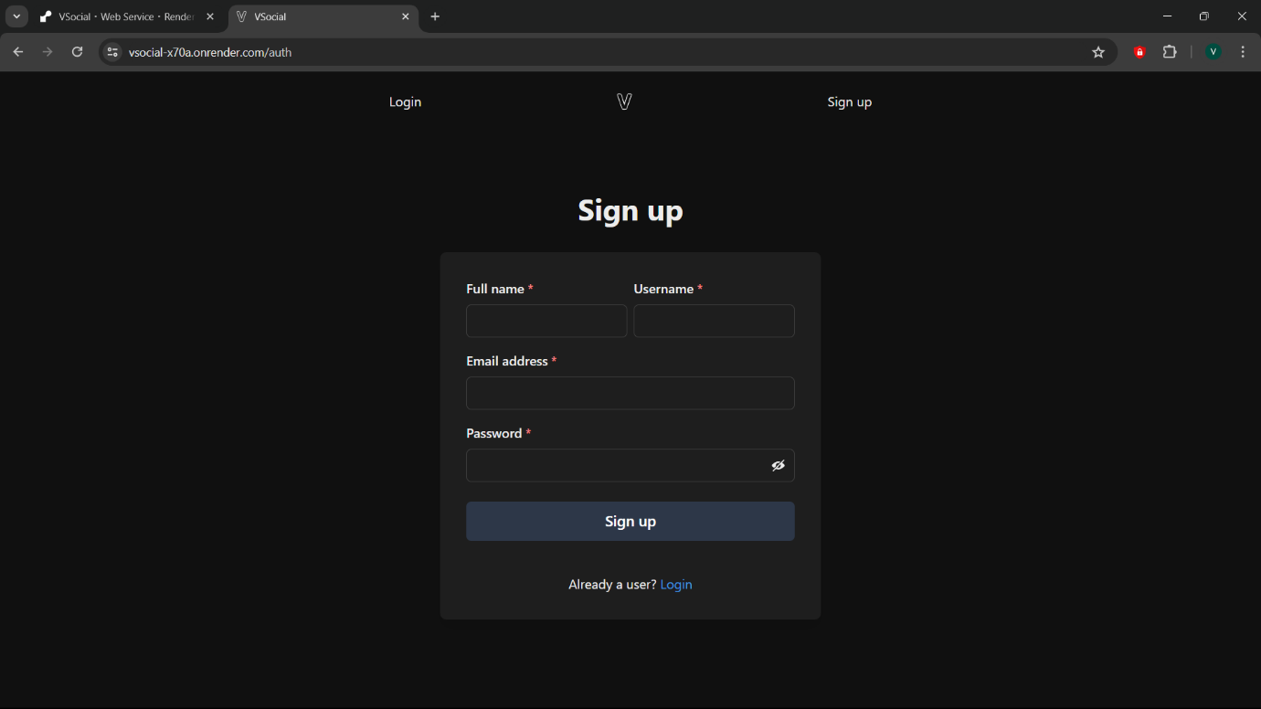

3. Home Page

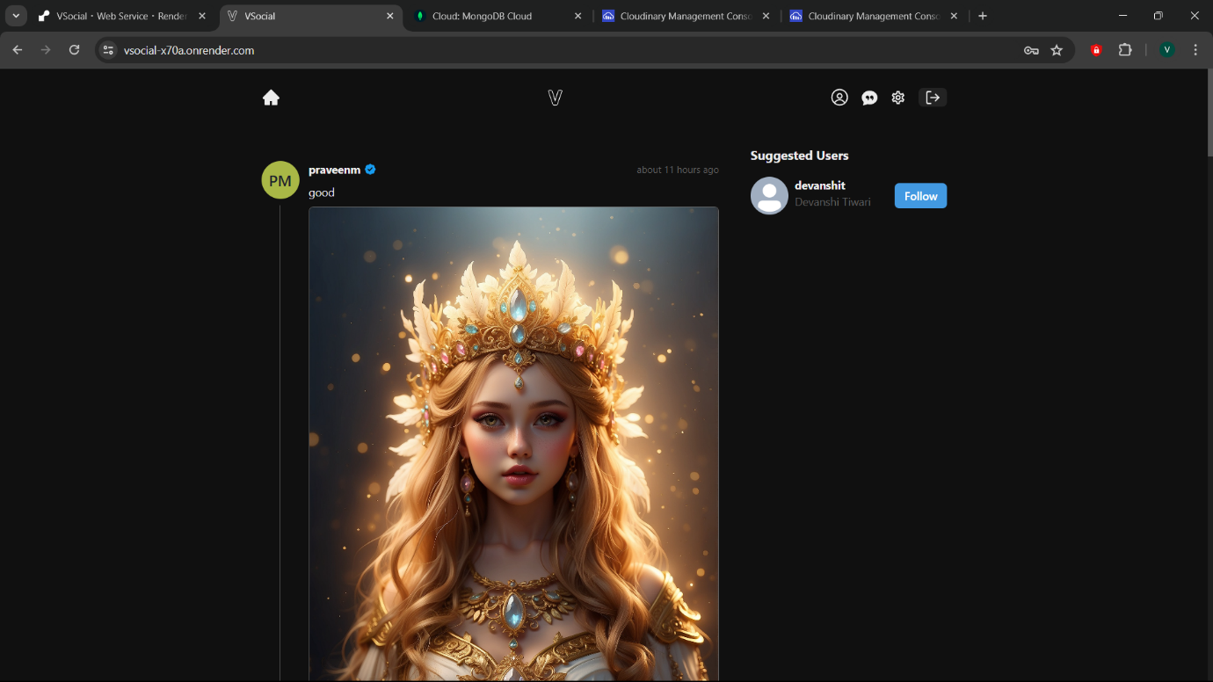

4. Account Page

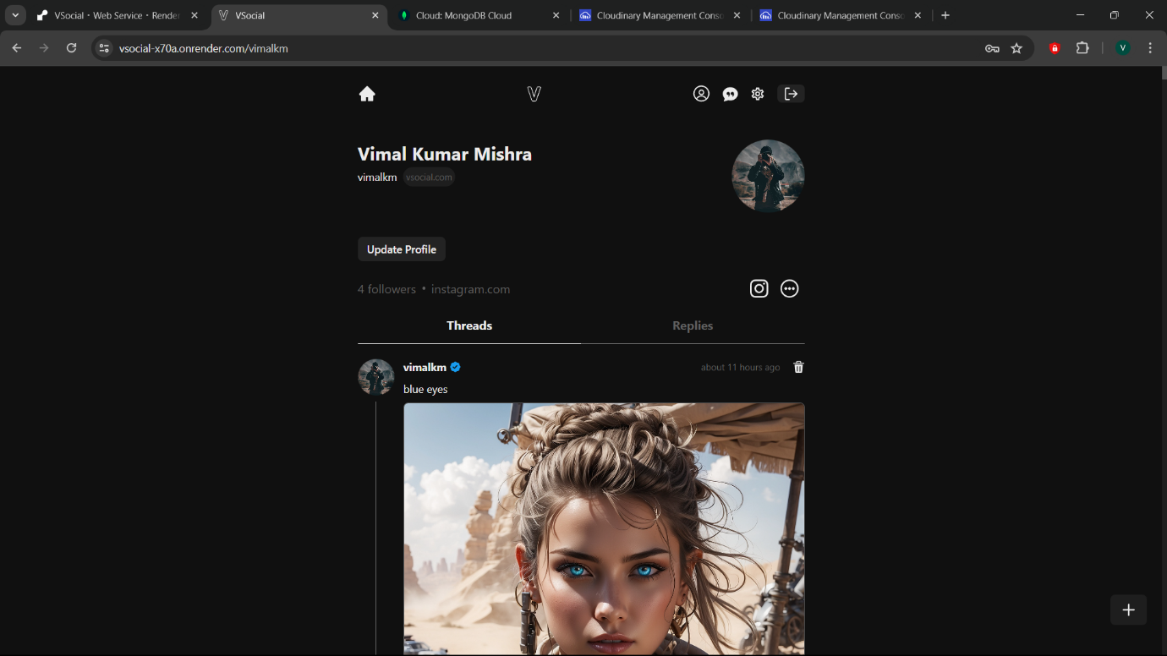

5. Update Profile Page

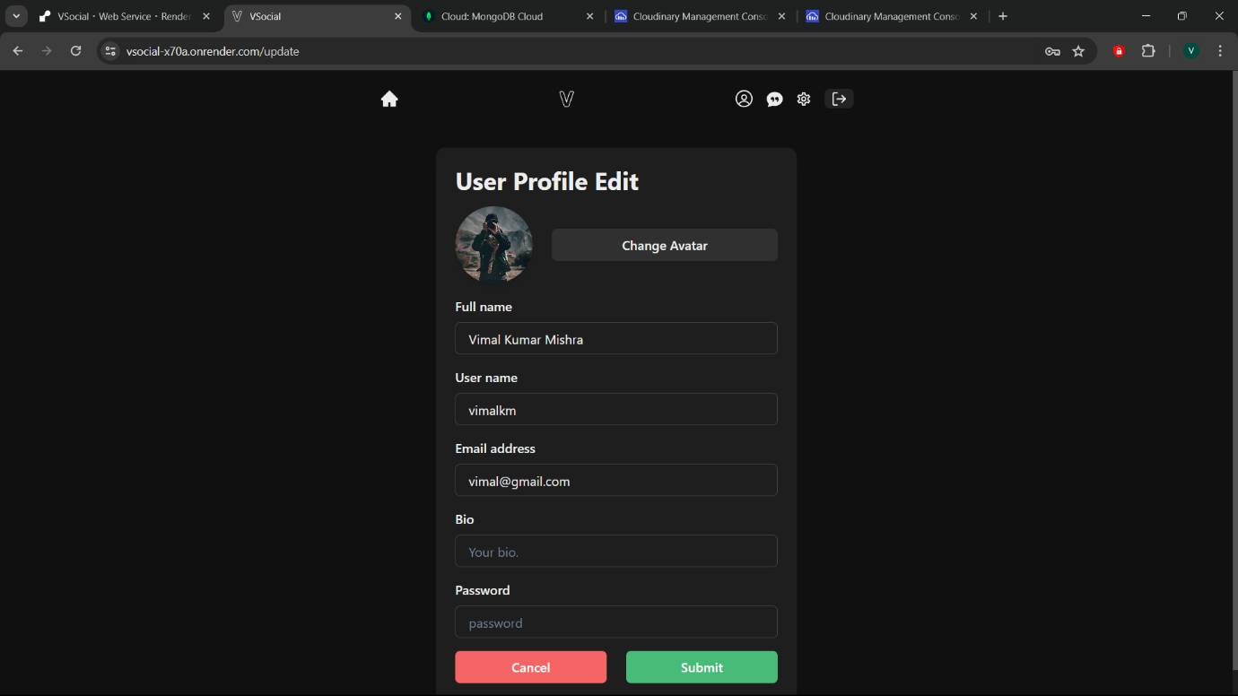

6. Setting Page

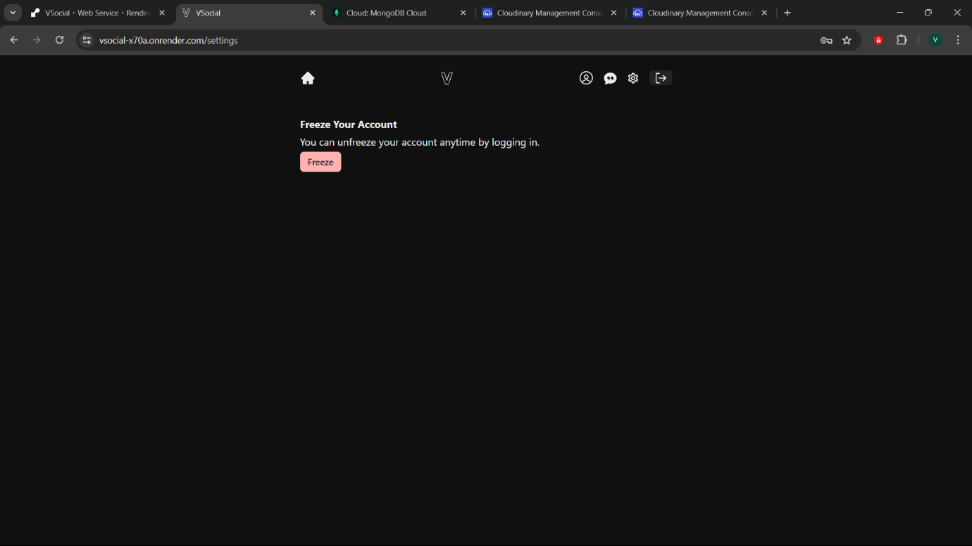

7. Chat Page

8. Light Theme

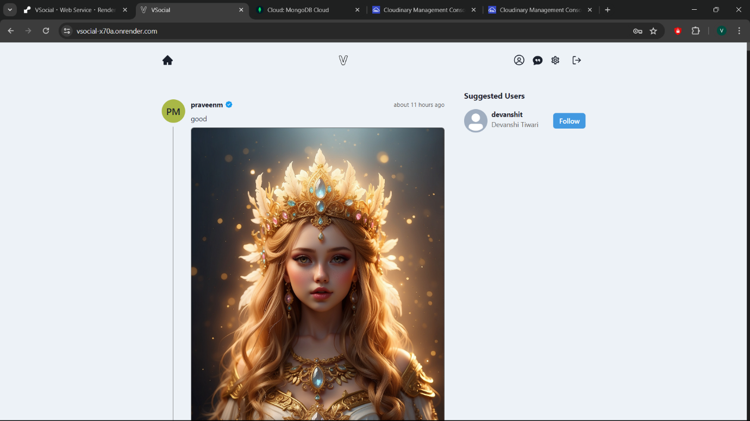

9. MongoDB Used for Storing Messages & Chats

10. Cloudinary Used for Storing Images

# ***REFERENCE***

REFERENCE: Google, YouTube, etc.

# ***GITHUB LINK***

LINK: https://github.com/VimalKMGithub/VSocial

# ***ONLINE APP LINK***

LINK: https://vsocial-x70a.onrender.com